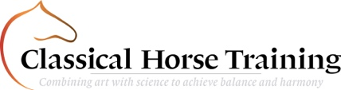
ONLINE LESSON APPLICATION FORM

Name
Horse
Date
Video link
Audio / Written feedback  Written feedback will approximately  take 2-4 days longer to process. | Audio / Written
Permission to archive in online portal? | Yes / No
Elements  (if a combination of multiple, please  select each relevant to your video) | Groundwork  In-hand  Lungeing  Ridden  Tackless  Long-Reigning
Exercises | Please fill in which exercises we can expect on the video and what the focus point of your training was.
Specific notes | Please fill in if you have a specific question, comment or note you’d like to ask or share with us.
Your own feeling/ feedback | Please let us know your own feeling about the training session filmed.
Send in completed form to: anne-roos@thirzahendriks.com
Do not forget to book your online meeting in the portal!

